LAB ACTIVITY (Lab-04)
// 1. Write a Java program to check if a number is positive or negative using an if statement

import java.util.*;
public class positive
{
public static void main(String[] args) {
int num;
Scanner sc=new Scanner(System.in);
System.out.println("Enter a number");
num=sc.nextInt();

if(num>=0){
System.out.println("The number is positive");
}
else
System.out.println("The number is negative");

}
}

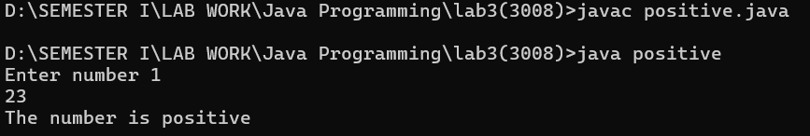

// 2. Write a Java program to check if a number is even or odd using an if-else statement.

import java.util.*;
public class odd
{
public static void main(String[] args) {
int num;
Scanner sc=new Scanner(System.in);
System.out.println("Enter a number");
num=sc.nextInt();

if(num%2==0){
System.out.println("The number is Even");
}
else
System.out.println("The number is Odd");

}
}

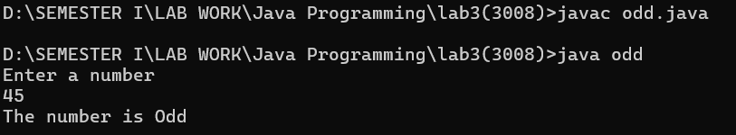

/* 3. Using if-else-if Ladder ,write a Java program to grade students based on their
marks:
Marks >= 90: Grade A
Marks >= 80: Grade B
Marks >= 70: Grade C
Marks < 70: Fail */

import java.util.*;
public class ifelsemarks
{
public static void main(String[] args) {
int marks;
Scanner sc=new Scanner(System.in);
System.out.println("Enter the marks");
marks=sc.nextInt();

if(marks>=90){
System.out.println("Grade A");
}
else if(marks>=80)
System.out.println("Grade B");
else if(marks>=70)
System.out.println("Grade C");
else
System.out.println("Fail");

}
}

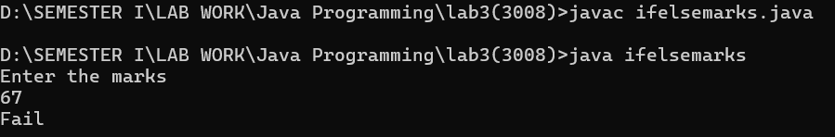

/* 3. Using Switch statement, write a Java program to grade students based on their
marks:
Marks >= 90: Grade A
Marks >= 80: Grade B
Marks >= 70: Grade C
Marks < 70: Fail */

import java.util.*;
public class switchmarks
{
public static void main(String[] args) {
int marks;
Scanner sc=new Scanner(System.in);
System.out.println("Enter the marks");
marks=sc.nextInt();

char grade;
if(marks>=90){
grade='A';
}
else if(marks>=80)
grade='B';
else if(marks>=70)
grade='C';
else
grade='F';

switch(grade){
case 'A':
System.out.println("Grade A");
break;
case 'B':
System.out.println("Grade B");
break;
case 'C':
System.out.println("Grade C");
break;
default:
System.out.println("Fail");
break;
}

}
}

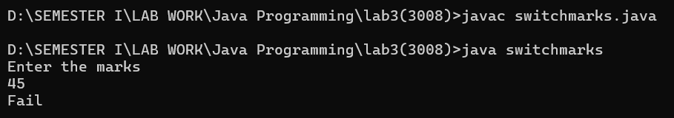

// 4. Write a Java program to check if a number is divisible by both 3 and 5

import java.util.*;
public class divisible
{
public static void main(String[] args) {
int num;
Scanner sc=new Scanner(System.in);
System.out.println("Enter a number");
num=sc.nextInt();

if(num%3==0){
if(num%5==0){
System.out.println("The number is divisible by both 3 and 5");
}
else
System.out.println("The number is divisible by 3 but not by 5");
}
else if(num%5==0){
if(num%3==0){
System.out.println("The number is divisible by both 3 and 5");
}
else
System.out.println("The number is divisible by 5 but not by 3");
}
}
}

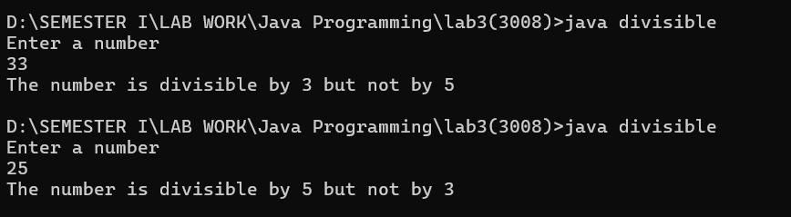

/* 5. Write a Java program to print the season based on the month number:
12, 1, 2: Winter
3, 4, 5: Spring
6, 7, 8: Summer
9, 10, 11: Autumn */

import java.util.Scanner;

public class season {

public static void main(String[] args) {
Scanner input = new Scanner(System.in);

System.out.print("Enter the month number (1-12): ");
int month = input.nextInt();

String season;

switch (month) {
case 12:
case 1:
case 2:
season = "Winter";
break;
case 3:
case 4:
case 5:
season = "Spring";
break;
case 6:
case 7:
case 8:
season = "Summer";
break;
case 9:
case 10:
case 11:
season = "Autumn";
break;
default:
season = "Invalid month number";
break;
}

System.out.println("The season for month " + month + " is: " + season);
}
}

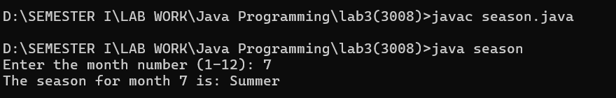

/* 6. Write a Java program to calculate the discount on a product based on its price:
Price > 1000: 20% discount
Price > 500: 10% discount
Otherwise: 5% discount */

import java.util.Scanner;
public class discount {

public static void main(String[] args) {
Scanner sc = new Scanner(System.in);

System.out.print("Enter the product price: ");
double price = sc.nextDouble();

double discountPercentage;

if (price > 1000) {
discountPercentage = 0.20;
} else if (price > 500) {
discountPercentage = 0.10;
} else {
discountPercentage = 0.05;
}

double discountAmount = price * discountPercentage;
double finalPrice = price - discountAmount;

System.out.println("Original Price: " + String.format("%.2f", price));
System.out.println("Discount Applied: " + (discountPercentage * 100) + "%");
System.out.println("Discount Amount: " + String.format("%.2f", discountAmount));
System.out.println("Final Price after Discount: " + String.format("%.2f", finalPrice));

}
}

